Fraud Detection Platform: Continuous Learning Automation Design
Oct 9, 2026 · @ayush

1. Document control
Item | Detail
Document | Continuous Learning Automation Design
System | Fraud Detection Platform (withdrawal risk scoring and Fraud Review panel)
Version | 0.1 (draft for review)
Organisation | MiraiGate Technologies
Audience | Engineering, operations, risk team and client stakeholders
Related document | Fraud Review Panel: Software Requirements Specification

Version | Date | Change
0.1 | 9 Oct 2026 | First draft for review

2. Executive summary
This design turns the fraud detection system into a closed learning loop: every decision a reviewer submits in the Fraud Review panel becomes a governed training label, the models retrain on a fixed schedule, and the panel shows refreshed scores without manual steps.
Today each update takes an analyst several hours of manual work: collecting exports, labelling cases, running seven scripts and copying files to the server. Reviewer decisions captured in the panel are not yet used in training.
The target state delivers four outcomes:
- Fresh scores every day. New withdrawal requests are pulled from the ingest service and scored with the current model within 24 hours, without retraining.
- Weekly learning. The models retrain every week, or earlier when 25 or more new reviewer decisions arrive, using reviewer decisions as the highest-priority labels.
- Safe releases. A new model goes live only if it passes defined quality gates against the model in production; otherwise the current model stays and the team is alerted.
- Full traceability. Every label, run and model version is recorded, and any release can be rolled back in one step.

3. Scope, objectives and success criteria
The automation covers the full path from a new withdrawal request on the platform to its refreshed score in the panel, including the retraining in between.
In scope
- Incremental intake of risk events from the ingest service
- Export of reviewer decisions, pattern answers and pattern notes from the panel
- Label rules, dataset build, retraining of the pattern, anomaly and fraud score models
- Quality gates, model registry, release, rollback and panel refresh
- Scheduling, monitoring, alerting and audit
Out of scope
- Changes to the client platform or to how agents approve withdrawals
- Real-time scoring at the moment of the withdrawal request (a later phase)
- Changes to the panel's review workflow other than the admin view in Phase 3
Success criterion | Target
New requests visible and scored in the panel | Within 24 hours of the request
Reviewer decisions used in training | 100% of decisions submitted before the run's cut-off
Manual steps per weekly update | 0 (approval optional, see open decisions)
Release of a model weaker than production | Never; blocked by quality gates
Time to roll back a release | Under 5 minutes
Failed or late runs | Alert to the team within 15 minutes

4. Current state
Each model update today is a manual sequence run by one analyst on one workstation, and reviewer decisions from the panel do not reach training.
Step | How it runs today | Machine time
1. Receive data | A risk-event JSON export (0.7 to 4 GB) is copied to the workstation | n/a
2. Register the file | The file is added by hand to the data preparation script | n/a
3. Prepare the dataset | All exports are re-read and features rebuilt from scratch | about 4 min
4. Label unclear cases | Analyst reviews rejects without a clear remark and agrees decisions in meetings | hours
5. Retrain | Pattern rules, pattern score, pattern test, anomaly update and fraud score model run one by one | about 3 min
6. Score and build panel data | Every request is rescored and the panel data files are rebuilt | about 9 min
7. Release | Files are uploaded to the panel server with a script and the service restarts | about 5 min
Gaps this design closes
- Reviewer decisions, pattern answers and notes in the panel are not used as labels.
- New requests reach the panel only after a manual update, so the queue can be days behind.
- The process depends on one person and one workstation, with no schedule.
- Models and datasets are overwritten in place; there is no registry, comparison report or one-step rollback.
- Failures and data problems are found only by inspection; there are no alerts.

5. Target architecture
Two inputs feed one pipeline: new risk events from the platform and reviewer feedback from the panel; a release reaches the panel only after the quality gates pass.
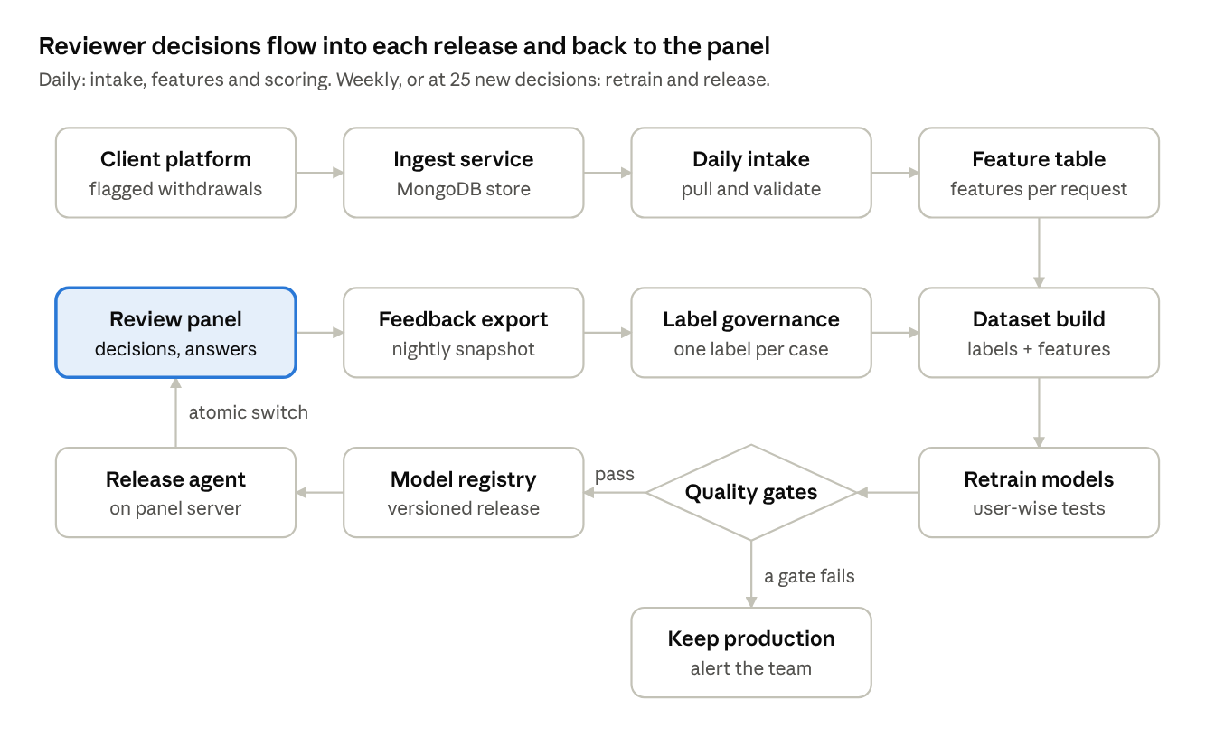
target architecture · data flow from platform and reviewers to the next release
The daily run stops after scoring and publishes fresh data with the current models. The weekly or feedback-triggered run goes through retraining and the gates; a failed gate keeps production unchanged.
Component | Role | Status
Ingest service | Receives flagged withdrawals from the platform | In place
Review panel | Reviewer decisions, pattern answers, notes; shows scores | In place
Object storage | Raw data, feedback, features, datasets, models, releases | New
Pipeline runner | Runs the stages in order on the training instance | New
Release agent | Pulls and switches releases on the panel server | New
Scheduler and alerts | Starts runs; reports failures and drift | New

6. Stage 1: Data ingestion
New risk events are pulled from the ingest service every day and stored once, in dated partitions, so no run ever re-reads the full history.
- Source. The platform already posts each flagged withdrawal, with the user's bets and statements, to the ingest service (POST /ingest), which stores it in MongoDB.
- Extract. A daily job calls a read-only export endpoint on the ingest service for records created or updated since the last successful watermark. Records keep their original _id, status, remarks, locks and the full activity bundle.
- Land. Each extract is written to object storage as a compressed file under raw/date=YYYY-MM-DD/. Files are never edited; a correction arrives as a newer version of the same record.
- Deduplicate. The latest version of each _id wins. A status change (for example approved to rejected) is kept as history, because labels use the final agent outcome.
- Validate. The job checks the schema, record count against the 7-day average, the share of records without bets or statements, and duplicate rate. A breach marks the batch as quarantined and alerts the team; scoring continues on the last good batch.
- Watermark. The job records the last processed timestamp only after the batch is stored and validated, so a failed run is simply repeated.
The manual JSON export remains available as a fallback: a file placed in the same raw/ location is picked up by the next run.

7. Stage 2: Reviewer feedback capture
The panel already records three kinds of feedback with full history; the automation exports a consistent snapshot of them every night.
Feedback | Captured in the panel | Used for
Decision | Fraud or Not fraud, a reason, reviewer, time, request id, score at the time | Training labels (highest priority)
Pattern answer | Does the known pattern fit this request: Yes, No, or Other with free text | Pattern examples and new-pattern discovery
Pattern note | Free-text note on P1 to P4, author and time | Read at each rule review; not a label
Export. At 23:30 IST a job on the panel server takes a consistent copy of the review database (SQLite backup API) and writes three files to feedback/date=YYYY-MM-DD/: current decisions, the full decision history, and pattern answers. The copy is read-only; the panel keeps working during the export.
Cut-off. A training run uses the latest export taken before it starts. Decisions submitted later go into the next run, and the run report states the cut-off time.
Integrity. Each export carries a row count and checksum. The training run refuses an export whose counts went down without a matching "cleared" entry in the history.

8. Stage 3: Label governance
Every request receives exactly one training label from a fixed order of evidence; a reviewer's decision in the panel always outranks the rules.
Priority | Evidence | Resulting label
1 | Reviewer decision in the panel: Fraud | Fraud example (client-confirmed)
1 | Reviewer decision in the panel: Not fraud | Genuine, even if the agent rejected the request
2 | Agent reject with a fraud remark, and the data shows a known pattern | Fraud example
3 | Agent reject with withdrawal lock, and the data meets a pattern rule | Fraud example
4 | Agent reject, platform error remark (wrong odds, technical issue) | Not fraud (excluded from the fraud class)
5 | Agent reject with no clear reason, old account (over 30 days), no lock | Excluded; scored from data only
6 | Agent reject with a lock but no pattern in the data | Excluded
7 | Approved, but the same user has a reject, or the data matches rejected cases (for example P2) | Excluded
8 | Approved, no doubt signals | Genuine
9 | No bets and no statements | Excluded (no data)
Pattern answers. "Yes, it fits" confirms the pattern tag of a fraud example. "No, it does not fit" keeps the label but removes the request from that pattern's examples, so the rule is not taught a wrong case. "Other" texts go to new-pattern discovery (section 13).
Conflicts. The latest decision on a player wins, and the full history is kept. When two reviewers gave opposite decisions within 7 days, the request is excluded from that run and listed in the run report for a lead reviewer to settle.
Label snapshot. Each run stores its label table with the source of every label (decision, rule number, reviewer), so any model can be traced back to the evidence it learned from.
Rules are reviewed, not frozen. Priorities 2 to 7 encode the current agreed practice. They are reviewed every month against reviewer decisions; a rule that reviewers often overturn is changed through the normal release process.

9. Stage 4: Dataset build and features
Features are computed once per request when it arrives and kept in a feature table, so retraining reads a few megabytes instead of re-reading 20 GB of exports.
- Feature table. For each new request the daily job computes the 59 behaviour features from the user's bets and statements up to the request time (20-day window), and stores them with the request id in features/date=YYYY-MM-DD/. Statements after the request time are never used.
- Training set. A run joins the feature table with the label snapshot (section 8). Data starts on 15 Sep 2026; older exports have too few bets and statements to use.
- Versioning. The training set is written to datasets/run=<run id>/ with its row count, label counts by group and pattern, and a content hash. The model registry points to it.
- Feature code changes. When the feature definition changes, a backfill job recomputes the feature table for the full history before the next training run, and the run report flags the change.
- Checks. Feature ranges and missing values are compared with the previous training set; a large shift stops the run before training.

10. Stage 5: Model retraining
The three models retrain together every Monday at 02:00 IST, and earlier when 25 or more new reviewer decisions have arrived since the last release (at most one extra run per day).
Trigger | When | What runs
Daily refresh | Every day, 03:00 IST | Intake, features, scoring with the current models, panel refresh. No training
Weekly retrain | Monday, 02:00 IST | Full retrain, quality gates, release if passed
Feedback trigger | 25 or more new decisions since the last release | Full retrain, same as weekly
Manual run | Admin starts a run with a reason | Full retrain or refresh, as chosen
Training order
- Pattern model (P1 to P4). Rule limits are re-derived from genuine requests (99th to 99.5th percentile), and the pattern score is rebuilt from the fraud examples of each pattern.
- Anomaly model (Layer 2) and group check (Layer 3). Trained on genuine requests only. The new version replaces the current one only if it catches at least as many hidden-pattern fraud examples and stays within the false-alarm limits (Layer 2 at most 3.5%, Layer 3 at most 0.6%).
- Fraud score model. Combines the pattern part and the behaviour part; regularisation is chosen by user-wise cross-validation (5 folds, 10 repeats), and the 0 to 99 scale is calibrated against approved requests.
Guarding against overfitting. The model design does not change between runs; only the data and labels grow. Tests always split by user, so no user is in training and testing at once, and each pattern is also tested with its own examples hidden.

11. Stage 6: Validation and quality gates
A candidate model is released only if it passes every blocking gate when compared with the production model on the same data; otherwise production stays as it is and the team is alerted with the report.
Gate | Check | Threshold | On failure
Data | Request count, share without data, label counts | Count within 30% of the 7-day trend; no-data share under 5%; fraud examples not fewer than last run unless explained in the label log | Block
Accuracy | AUC, fraud score, user-wise test | Not more than 0.005 below production | Block
New patterns | AUC with each fraud example's own pattern hidden | Not more than 0.01 below production | Block
False alarms | Approved requests scored 90% or more | 0.1% or less | Block
Catch rate | Fraud examples caught at 1% false alarms | Not more than 5 points below production | Block
Reviewer agreement | Ranking of fraud vs not-fraud decisions made since the last release | Reported; under 0.80 is flagged | Warn
Score shift | Requests whose score moves by more than 20 points | Reported; over 10% of requests is flagged | Warn
Queue size | Players in the review queue (60% or more) | Reported; change over 30% is flagged | Warn
Every run produces a comparison report: metrics for production and candidate side by side, label changes since the last run, and the 20 requests whose scores moved most. The report is stored with the run and linked in the notification.

12. Stage 7: Release, panel refresh and rollback
A release is a versioned package that the panel server pulls and switches to atomically, so the panel never shows a half-updated state and any earlier release can be restored in one step.
Model registry. Each run that passes the gates is stored under models/v<NNN>/ with a manifest: models, training set reference, label snapshot, code version, metrics, gate results, cut-off times and the approver (if approval is enabled). Registry entries are never edited or deleted.
Rescoring. After a release, all requests from 15 Sep 2026 are rescored with the new models. Training records keep their out-of-fold scores, so the panel shows honest scores for the cases the model learned from.
Panel package. The run builds the panel data files (request tables and activity store) and writes them to releases/r<NNN>/ with a manifest and checksums. The daily refresh produces the same package with the current models.
Deployment (pull, not push). A small agent on the panel server checks releases/ every 10 minutes. On a new manifest it downloads the files to a staging folder, verifies the checksums, swaps the data folder in one rename, and restarts the service. Reviewer decisions, pattern answers, notes and accounts are never touched. No pipeline job holds login keys to the panel server.
Rollback. An admin selects an earlier release in the panel's admin view (Phase 3) or runs one command on the server. The agent switches back to that release within 5 minutes. A rollback is logged with the user and reason.

13. New pattern discovery
A new pattern (P5 onwards) is proposed automatically once reviewers have marked at least 3 different users as fraud under the same pattern name, and it goes live only after the client approves it.
- Naming in the panel. When a reviewer marks a request as fraud and no known pattern fits, the review box offers "Other" with a pattern name and a short description. Names already used are suggested, so the same pattern is not spelled three ways.
- Candidate rule. The weekly run groups confirmed cases by pattern name. For a name with 3 or more users, it searches for at most 3 conditions that all cases share and that genuine users rarely meet (top or bottom 5%), with limits set from genuine data.
- Test. Each case is left out in turn and the rule rebuilt; the report shows how many left-out cases are still caught and the false-alarm rate on genuine requests.
- Approval. The candidate appears in the panel's admin view with its conditions, cases, test results and expected daily alerts. The client approves or rejects it; nothing is applied without approval.
- Use. An approved rule joins the pattern model in the next run, appears on the Known patterns page, and its matches show "Matches known pattern P5".
If the cases share no clear condition, no rule is proposed and the report says why: the cases may be of different kinds and need separate names, or more cases are needed.

14. Orchestration and scheduling
One pipeline runner executes every run as a fixed sequence of stages; the daily refresh skips training, and a failed gate falls back to scoring with the current models, so the panel is refreshed either way.
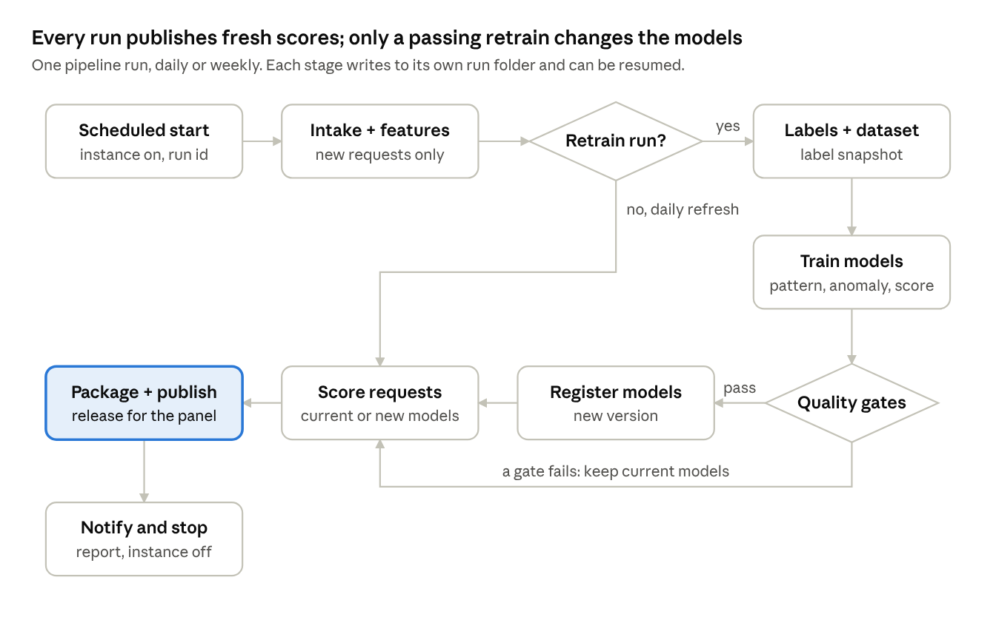
pipeline run · daily refresh and retrain paths
Runner. A single command, pipeline run --mode daily|retrain|manual, runs on the training instance. The scheduler starts the instance, the runner executes, writes the run manifest and logs, sends the notification, and shuts the instance down.
Idempotent stages. Each stage reads only the outputs of earlier stages and writes to runs/<run id>/<stage>/. A failed run is resumed from the failed stage with the same inputs; a stage that already succeeded is not repeated.
Retries. Network and capacity errors are retried 3 times with growing waits (1, 5 and 15 minutes). Data and gate failures are not retried; they need a person.
Concurrency. Only one run at a time. A trigger that arrives during a run is queued; two queued triggers merge into one run.
Run state | Meaning | Panel effect
Queued | Waiting for the current run to finish | None
Running | Stages in progress | None
Released | Gates passed; new models and data published | New scores and models
Refreshed | Daily run, or gates failed; data published with current models | New requests, same models
Quarantined | Input data failed checks | None; last release stays
Failed | A stage failed after retries | None; last release stays

15. Monitoring, alerting and reporting
The team is told within 15 minutes when a run fails, data stops arriving or the scores drift, and stakeholders receive a weekly summary.
Signal | Measure | Alert when
Run health | Run status and duration by stage | Any stage fails, or a run takes over 2 times its usual time
Data freshness | Age of the newest request in the panel | Older than 6 hours during the day
Data quality | Batch count, no-data share, duplicates | Batch quarantined (section 6)
Score drift | Distribution of scores vs the last 4 weeks (population stability index) | Index over 0.2
Review backlog | Players waiting in the queue, oldest waiting request | Oldest over 48 hours
Model quality | Gate metrics per release, reviewer agreement | A gate fails or agreement falls below 0.80
Panel availability | Sign-in page and data check every 5 minutes | Two failed checks in a row
Notifications go to the operations channel (email or chat, see open decisions) with the run id, the outcome and a link to the report.
Weekly summary (Monday after the retrain): requests scored, decisions received, labels added, release outcome and metrics against the previous week, and the top changes in the review queue.

16. Security, access control, audit and retention
Each component gets only the access it needs, client data stays encrypted inside the company's cloud account, and every label, run and release can be audited.
Component | Can read | Can write
Intake job | Ingest service export endpoint (read-only token) | raw/, features/
Feedback export (panel server) | Review database | feedback/
Training jobs | raw/, features/, feedback/, models/ | datasets/, models/, releases/, run reports
Panel release agent | releases/ | Local panel data folder only
Reviewers | Panel pages and data | Decisions, pattern answers, notes
Admins | Run reports, registry, admin view | Manual runs, approvals, rollback
Controls
- Object storage encrypted at rest, versioning on, public access blocked; access through instance roles, not stored keys.
- The training instance accepts no inbound connections; it is started by the scheduler and stops after the run.
- The ingest service's database stays internal; the intake job uses a separate read-only export token, rotated every 90 days.
- Panel sign-in, one browser per account and sign-in limits stay as they are; admin actions need an admin role.
Audit. Decision history, pattern-answer history, run manifests, label snapshots, registry entries and rollbacks are kept for the life of the system. Each records who, what and when.
Retention (proposed). Raw exports 12 months, feature tables and training sets 24 months, run reports and registry indefinitely. Final periods are an open decision (section 20).

17. Infrastructure and cost estimate
The automation adds roughly USD 15 to 25 a month to the current setup, because training runs on an instance that is switched on only for the run.
Component | Proposed resource | Usage | Approximate monthly cost
Review panel | Existing EC2 t3.medium, 40 GB gp3 | Always on | Already in place
Ingest service | Existing EC2 with MongoDB | Always on | Already in place
Training and scoring | EC2 m6i.xlarge (4 vCPU, 16 GB), started on schedule | About 30 min daily, 1 hour weekly | USD 5 to 8
Object storage | S3, encrypted, versioned | Grows about 30 GB a month | USD 2 to 10, growing
Scheduling and logs | EventBridge Scheduler, CloudWatch Logs and alarms | Daily and weekly triggers | Under USD 5
Notifications | Email (SES) or chat webhook | A few messages a day | Under USD 1
Costs are approximate list prices for the Mumbai region and exclude tax; they should be confirmed in the AWS pricing calculator before sign-off. Spot instances can cut the training cost further, with an automatic retry on on-demand if a spot run is interrupted.

18. Risks and mitigations
The largest risk is a feedback loop in which the model learns only from the cases it already scores high; the design counters it with a random review sample and with gates that compare every release against production.
Risk | Effect | Mitigation
Selection bias: reviewers see mostly high-score cases | The model never learns the fraud it misses | Each week 20 random requests below 60% enter the queue as a "spot check"; their decisions are labelled like any other
Inconsistent decisions between reviewers | Noisy labels, unstable scores | Required reason, conflict rule (section 8), monthly calibration review of disagreements
Few fraud examples (62 today) | Overfitting, large swings between runs | Fixed model design, user-wise tests, hidden-pattern test, gates on drops
Platform changes the data format | Intake fails or features go wrong | Schema check and quarantine; scoring continues on the last good batch
A weaker model is released | Wrong cases in the queue | Blocking gates, comparison report, one-step rollback
Panel updated while reviewers work | Confusing or lost work | Atomic swap; decisions stored separately and never overwritten
Credentials or data exposure | Client data leak | Role-based access, no stored keys, encryption, no inbound access to training
Dependence on one person | Delays when unavailable | Scheduled runs, runbooks, alerts to a shared channel

19. Implementation roadmap
Phase 1 delivers the most important change first: within two weeks, every reviewer decision is used in the next retrain; full automation follows by week 6.
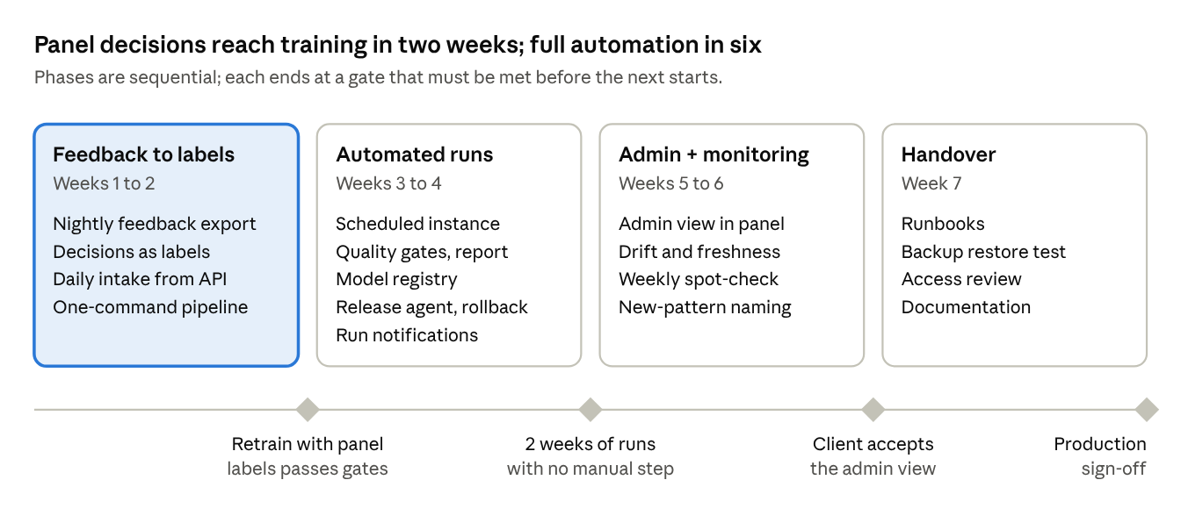
implementation roadmap · 4 phases, 7 weeks, a gate at the end of each
Phase 1 closes the gap the panel's notification already promises to reviewers ("used to retrain the model at the next update"). Until Phase 2 is live, the weekly retrain is started by hand with the single pipeline command. Durations assume one engineer and timely sign-off on the open decisions in section 20.

20. Open decisions requiring sign-off
The design uses the proposals below; each needs confirmation before Phase 2 starts.
Decision | Proposal in this design | Alternative
Retraining cadence | Weekly, plus an early run at 25 new decisions | Weekly only, or nightly
Where training runs | Separate instance, started only for the run | Panel server, or the analyst's workstation
Release of a new model | Automatic when all gates pass; admin can roll back | Admin approval in the panel before each release
Data intake | Daily pull from the ingest service | Manual JSON export
Score floor for training fraud examples | To be decided: today these cases and the same users' later requests show at least 95% | Show the model's own score only
Spot-check sample | 20 random low-score requests a week | Another size, or none
Data retention | Raw 12 months, features 24 months, reports indefinitely | Periods set by the client's policy
Notification channel | Email to the operations group | Chat channel
Approvers | One lead reviewer from the client and one admin from MiraiGate | Named list

21. Glossary
Term | Meaning
Risk event | A withdrawal request flagged by the platform, with the user's bets and statements
Review panel | The web application where client reviewers check flagged players and submit decisions
Decision | A reviewer's Fraud or Not fraud verdict on a player, with a reason
Pattern answer | A reviewer's Yes, No or Other answer on whether a known pattern fits a request
Known pattern | A confirmed fraud behaviour with a rule: P1 casino winnings, P2 small deposit then large casino win, P3 back and lay, P4 bonus with no deposit
Anomaly model | A model trained on genuine requests that scores how different a request is from normal users (Layer 2)
Group check | Finds 3 or more similar unusual users under one master within 72 hours (Layer 3)
Fraud score | The 0 to 99 score shown in the panel, calibrated against approved requests
Label | The training category of a request: fraud example, genuine, not fraud or excluded
Out-of-fold score | A score for a training record from a model that did not see that record
Quality gate | A check a candidate model must pass before release
Model registry | The versioned, read-only store of released models and their evidence
Release | A versioned package of models and panel data that the panel switches to
Watermark | The timestamp up to which data has been ingested successfully

